AI Cooking Manger – Ghost CookKing

Bulgogi Warriors

Ju Sanghan 2016026544  
College of Engineering, *Hanyang University*  
Dept. of Information SystemSeoul, Korea  
wntkdgks4076@gmail.com

Valiukenas, Airidas Tomas 9098820217  
College of Engineering  
*Hanyang University*  
Dept. of Program SystemSeoul, Korea  
airidas.valiukenas@ktu.eduLee Wonsuk 2016026426   
College of Engineering, *Hanyang University*  
Dept. of Information SystemSeoul, Korea  
lws1516@naver.com

Kouadio, Laura 9109720216  
College of Engineering, *Hanyang University*  
Dept. of Electronics and Computer ScienceSeoul, Korea  
laura.kouaio@ensea.fr Lee Jun I 2018007674   
College of Engineering, *Hanyang University*  
Dept. of Information SystemSeoul, Korea*)*  
lji123ji-@naver.com

*Abstract* — Our team is trying to create an AI cooking assistant - Ghost Cooking King - using NUGU speaker. The ultimate goal is to give a user experience such as having a skilled kitchen assistant. The service is linked to LG's Signature Kitchen Suite and recommends some dishes depending on the ingredients that already exist in the refrigerator and user order. (like exotic, easy-cook etc.) As you select a recommended dish and amount of your cooking, shopping lists are provided. When you start cooking, you will be informed of the optimal time and intensity of the fire and detailed methods to cook step by step as if a person is next to you. This service could be improved when combined with smart kitchen, such as automatically adjusting the intensity of fire, timer, stove hood, the oven, etc.

Role Assignments

| ***Roles*** | Name | Task Description and etc. |
| --- | --- | --- |
| User | Lee Won suk | Responsible for looking at the software through the perspective of an average user and giving feedback on the user experience. It’s done by assuming the user's point of view and trying out if the interface is user-friendly. |
| Customer | Kouadio, Laura | Main responsibility is to give the requirements of the software and when the features are delivered to review them. Through the whole process of development communicates with the development team about the way the project is going. |
| Software Developer 1 | Valiukenas,Airidas Tomas | Responsible for writing and developing software features and satisfying the needs of the customer. Implements the features of the project and if needed, adapts to the feedback given. |
| Software Developrt 2 | Lee Jun I | Responsible for writing and developing software features and satisfying the needs of the customer. Implements the features of the project and if needed, adapts to the feedback given. |
| Developer manager | Ju Sang Han | Supervises the development of the service, managing deadlines and evaluation of software features. Also gathers information from user and customer if everything is going according to the needs expressed by them. |

# Introduction

## Motivation

We focused on Cooking Manager that makes more comfortable with cooking, and made this service. Although the number of single-person households has increased and delivery services in the COVID-19 era have become rapidly popular, there are many problems such as high prices, too much food to eat alone, and trash such as plastic. Most of the people who live alone, when they first start living alone they start chasing the dream of cooking, but after cooking for a few days, they lose interest in cooking and live a life of not cooking ever again. However, people still feel the need to cook alone, and most people are willing and want to cook if the conditions are met. Probably, there are surplus ingredients, difficulties in cooking itself (entry barriers), and the hassle of washing dishes so even those who do not cook at all want to cook well alone. (we will do a survey) So we thought it would be nice to teach users how to cook using an AI speaker. However, people want to follow step by step tutorials through YouTube or cookbooks, but it is difficult to follow the process as it is, and it is too much for beginners to memorize the entire process. Also, it is too hectic to refer to videos or read books while cooking in the kitchen. Therefore, if users are a beginner, they will be interested in cooking, and a teacher right next to them. Further, if a user is used to cooking, this service will provide a user experience like having a kitchen assistance.

In addition to making the cooking stage easy, we were also interested in making the preparation stage comfortable. It would be convenient to know what recipes you can cook with the remaining ingredients in the refrigerator and how much shopping you need. We plan to make an AI agent to recommend on its own according to the needs of users. For example, if a user makes a command such as exotic, easy-to-cook, or special food for anniversaries, suitable recipes are recommended.

## Problem statement

In the case of beginners living alone, ingredients often pile up in the refrigerator. If the remaining ingredients are left unattended, there is a problem of damaging and throwing them away. If there is a service that recommends dishes and recipes that can be made using leftover ingredients in the refrigerator, users' satisfaction will also increase as they can prevent waste of ingredients and taste various dishes.

## Research on any related software

a) SuperCook

There are various applications on the app stores and counterparts on the web that work by inputting ingredients, and it gives you a recipe you can do with the ingredients. An example: SuperCook – it is both a web and a mobile application in which you can select ingredients from various categories and after every ingredient inputted the service updates what recipes you can make with the ingredients you have. You can filter out what meals or cuisine that you want. You can also have a profile to make the process easier.

b) Hub Cooking

A service out in the market is Google Home‘s Hub Cooking. The way it works is you can say to the AI speaker assistant that you want a recipe. It gives you a recipe and after you choose it either through voice commands or through touch control, you can ask for a list of ingredients. After that you can navigate through the steps of the cooking process using voice commands.

c) Giga Genie

There is an artificial intelligence speaker service called KT's Giga Genie. Giga Genie also supports smart recipe functions. It's the ‘10,000 recipes’. The main feature of ‘10,000 recipes’ is that they actually support the recipes of people who are famous for cooking. For example, it can bring recipes from famous Korean celebrities such as Baek Jong-won and Kim Soo-mi. It also supports the ability to send recipes brought into mobile phones.

d) TinyChef

TinyChef is a mobile app which can function through Alexa or Google Home or simply through the usual phone interface. Its main features are the ability to search for recipes with different filters, also it can plan the meals based on dietary requirements and make shopping lists. Another feature is the ability to one-click purchase the delivery of the groceries. Furthermore, it has the recipe step-by-step guidance feature.

e) Cooksy

A different kind of service is Cooksy. It’s a new project that is an AI based gadget that can be attached in the kitchen which can help through the cooking process. It observes the process of you cooking live, by watching the temperature, ingredients. It can also lead through the recipe with the help of voice commands.

# Requiremets

A. AI Speaker

a) ingredient-based recommendation service.

1) user should input the ingredients left in the refrigerator.

2) Get name of the dish and recipe method.

3) The speaker will tell the result of information

b) service to get recipes through name of dish

1) user should input name of dish to speaker.

2) Get ingredient used dish and recipe method

3) The speaker will tell the result of information

B. Application

a) sign- in

1) To identify users, user’s ID is required

b) Input ingredients to app

c) Send the input ingredients to the server

C. Server

a)Compare the ingredients with the ingredients of the dish in the dataset.

b)Get the most correlated cooking data with the ingredients you input

c)Get name of dish, ingredients, recipe

4)Make json for NUGU

a) Server should make json file. NUGU Speaker demand data in REST API form

# DEVELOPMENT ENVIRONMENT

## Choice of Software Development Platform

a) Which platform and why? (e.g., Windows, Linux, Web, or etc.)

We will go to use Windows 10 and macOS. Windows

10 is a series of personal computer operating systems

produced by Microsoft. According to the data onto ’Usage

share of operating systems’, in the area of desktop

and laptop computers, Microsoft Windows is generally

above 70% in most markets and at 77% globally. Then,

it could be familiar to both of users and developers and

decided to use. On the other hand, macOS is a Unixbased

operating system and is a popular choice since

lots of people prefer using Mac so we also choose it for

developing.

b) Which programming language?

a) Python 3.8



Python is an interpreted, high-level and general-purpose programming language. Created by Guido van Rossum and first released in 1991. We use python for developing backend server. because it is one of the most popular programming language for developing an artificial-intelligence-related-program. Moreover, it can be run on various OS, including Microsoft Windows, Mac OS, and Linux OS.

b)Javascript

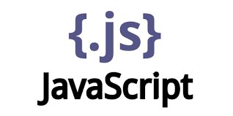

Javascript is a high-level, interpreted scripting language that conforms to the ECMAScript specification. Javascript has flexible grammars: freedom from indentation, loose type checks. Also, it adopts modern programming paradigms and has convenient and great features: function programming, reactive programming. We use JavaScript for our android application development.

## Cost estimation for your built

|  |  |
| --- | --- |
| **Name of software** | **Cost** |
| **AWS EC2** | **0** |
| **Nugu play builder** | **0** |
| **Github** | **0** |
| **Notion** | **0** |
| **Jupyter Notebook** | **0** |

## Software in Use

a) AWS EC2

AWS has significantly more services, and more features within those services, than any other cloud provider–from infrastructure technologies like compute, storage, and databases–to emerging technologies, such as machine learning and artificial intelligence, data lakes and analytics, and Internet of Things. This makes it faster, easier, and more cost effective to move your existing applications to the cloud and build nearly anything you can imagine. AWS also has the deepest functionality within those services. For example, AWS offers the widest variety of databases that are purpose-built for different types of applications so you can choose the right tool for the job to get the best cost and performance.

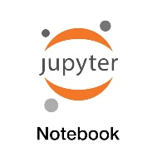b) Jupyter notebook

The Jupyter Notebook is an open-source web application that allows you to create and share documents that contain live code, equations, visualizations and narrative text. Uses include: data cleaning and transformation, numerical simulation, statistical modeling, data visualization, machine learning, and much more.

**c) Flask**

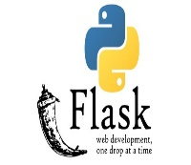

On top of python, we use Flask framework for the server. We will construct a server with AWS EC2 and control it with Python and Flask framework. Flask is famous for its lightness, simplicity, and speed.

**d) React Native**

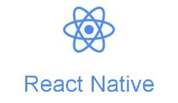

React Native is a JavaScript framework for writing real, natively rendering mobile application for Android. It’s based on React, Facebook’s JavaScript library for building user interfaces, but instead of targeting the browser, it targets mobile platforms. React Native applications are written by JavaScript.

**e) Android Studio**



The IDE itself is based off the very popular IntelliJ IDEA from JetBrains and is being offered by Google for free. On the other hand, Eclipse is more mature than ever and Google’s ADT plugin which transforms the popular IDE into a fully featured Android developing environment has become very stable. Instead, lots of developers want to get associated with Android application because of incredible growth. Besides, Android Studio platform developers also use Eclipse to develop applications, but always thought of Eclipse like a “StudentProject IDE (Integrated Development Environment)” and learned about it

**f) GitHub**

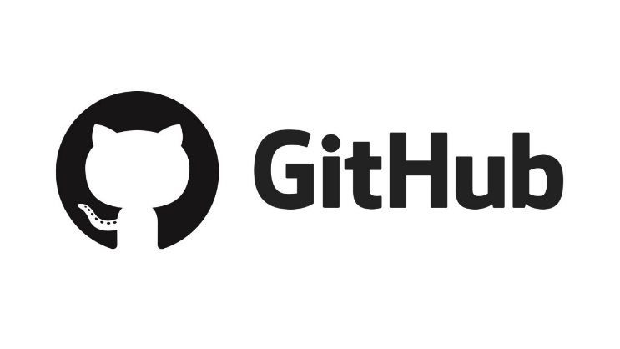

GitHub is a Git repository hosting service, but it adds many of its own features. Git is a command line tool and GitHub provides a Web-based graphical interface. It also provides access control and several collaboration features, such as a wikis and basic task management tools for every project. This will help us to co-work each other and see our own code more easily. In addition, various open sources of sign language will be provided and will help us use them directly and indirectly.

## D.Task Distribution

|  |  |
| --- | --- |
| Name | Task |
| Lee, Jun I | Backend & NUGU |
| Valiukenas, Airidas Tomas | Frontend |
| Lee Wonsuk | Backend & NUGU |
| Ju Sanghan | Backend & NUGU |
| Kouadio, Laura | Frontend |

# SPECIFICATIONS

*A. AI Speaker*

a) Create user utterance model: It refers to creating training data that predicts the user’s utterance and learning the engine based on the data. Utterance model divided into two parts. Intent and Entity parts

1) intent refers to a user’s intention. Intent can be divided to custom intent and built-in intent. Custom Intent refers to Intent defined within Play, and Built-in Intent is an Intent provided by NUGU play kit that is expected to be commonly used in many fields, so it has been trained in advance. Intent stores the user's intention, and identifies the intention to perform a specific action.  
Cook King is. starts with precondition called “ask.start” and is divided into different Branch Actions according to the user's utterance.

2)Entity: Entity is created and defined based on the type. The Entity type consists of Custom and Built-in Entity type. In order to understand a person's speech, it is necessary to learn various and many entities. When there are multiple words referring to one entity, it can normalize by adding synonyms.

b) Create action: Action is to deal with the intents defined in the User Utterance Model, which was created in anticipation of the user's utterance, when they are actually analyzed through the NLU engine, that is, action serves to answer or perform commands on the user's utterance within the play.

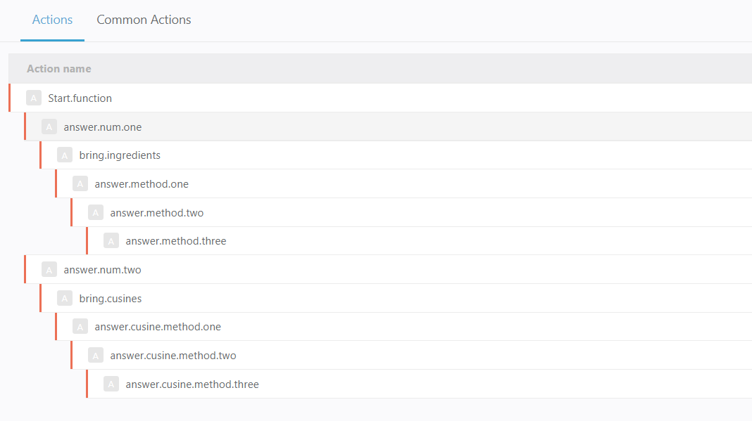

Figure.1 (A brief direction of action)

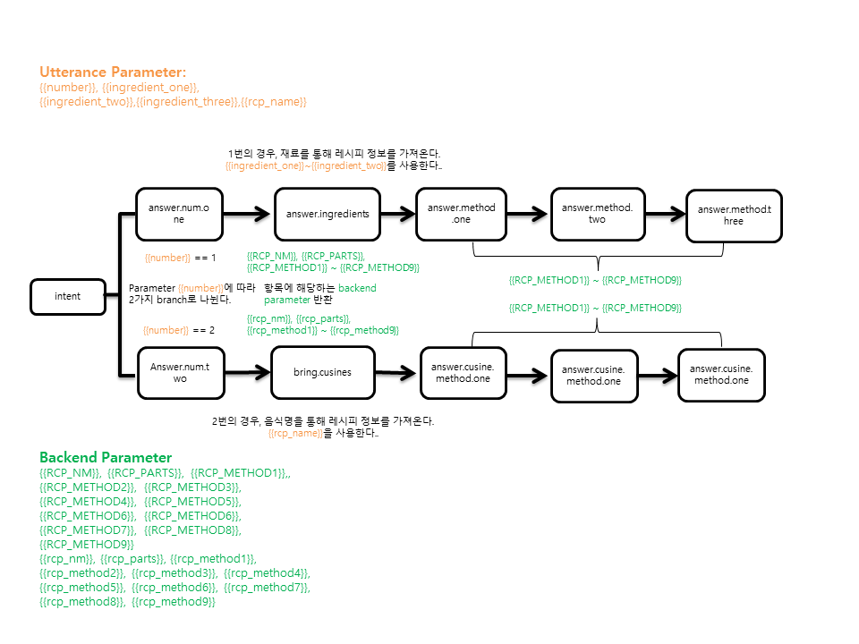

Figure.2 (Show how parameters progresses in CookKing’s action)

*B. Application*

The application can be divided into two parts. Sign-in and up and main pages.

a) Sign-in

To use the application the user first must Sign-in with his created profile. There are 2 fields to input information and if the user’s inputted information is correct, on pressing the login button the user is signed in and redirected to the home screen of the application.

b) Sign-up

To be able to sign-in the user must create an account. On the sign-up page there are 3 fields for the user to input his information. Once the user inputs the correct information and presses the sign-up button and verifies his email, an account is created with which the user can sign-in to the application.

c) Main page

1) The ingredient page allows the user to enter every ingredient he has at home to cook. Based on that list of ingredients, the CookKing application will propose a suitable recipe. To enter an ingredient, the user simply has to insert its name in the search bar and then press the “+” button. As soon as the user starts typing, a clear button appears, allowing the user to erase everything in the search bar all at once. The user can remove an ingredient from the list at any time by pressing the “x” next to the name of the ingredient.

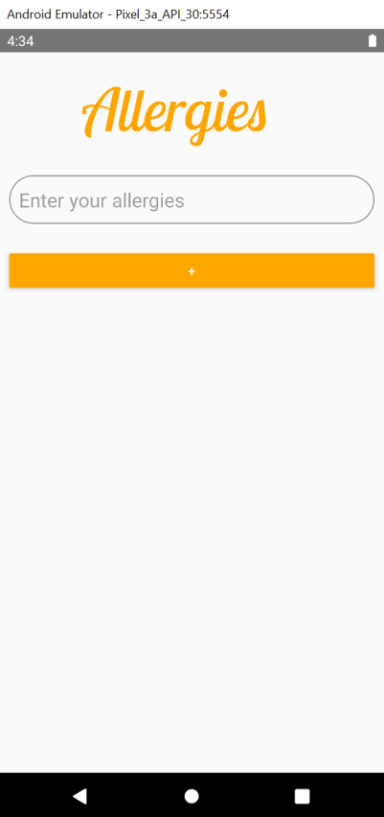

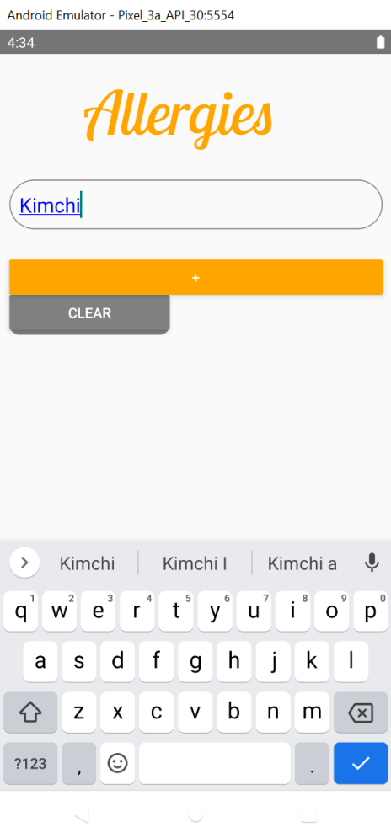

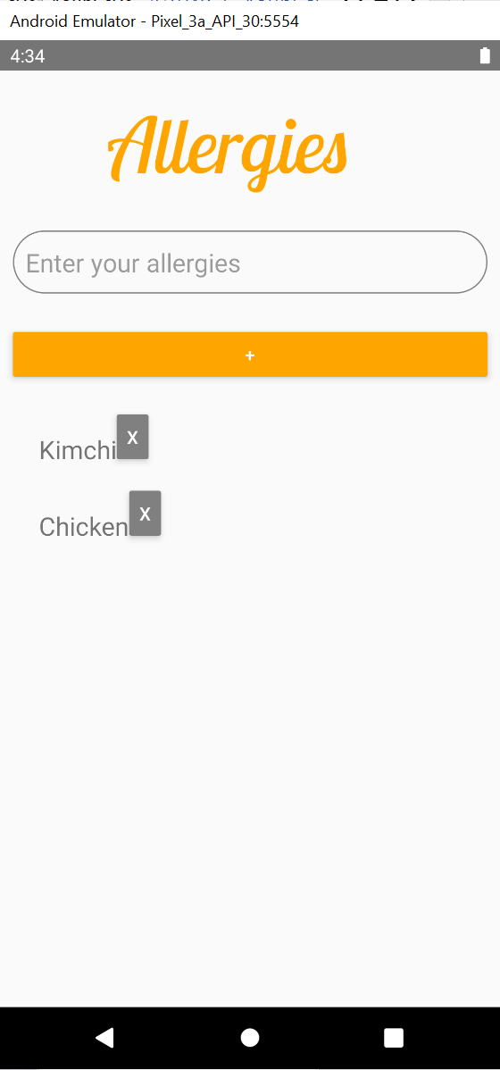

2) Guidelines during the cooking process:

After calculation, Ghostcooking application will propose several recipes to the user. The user will then be able to choose one option and start cooking. To do so, will only have to press the “요리를 합시다” button, located under the bell. After pressing that button, the NUGU speaker will start explaining the first step of the recipe of the user. In the aim to maximize the chances that the user will succeed to make the given recipe, videos or images will be displayed through the application to help the user understanding what the NUGU speaker is explaining.

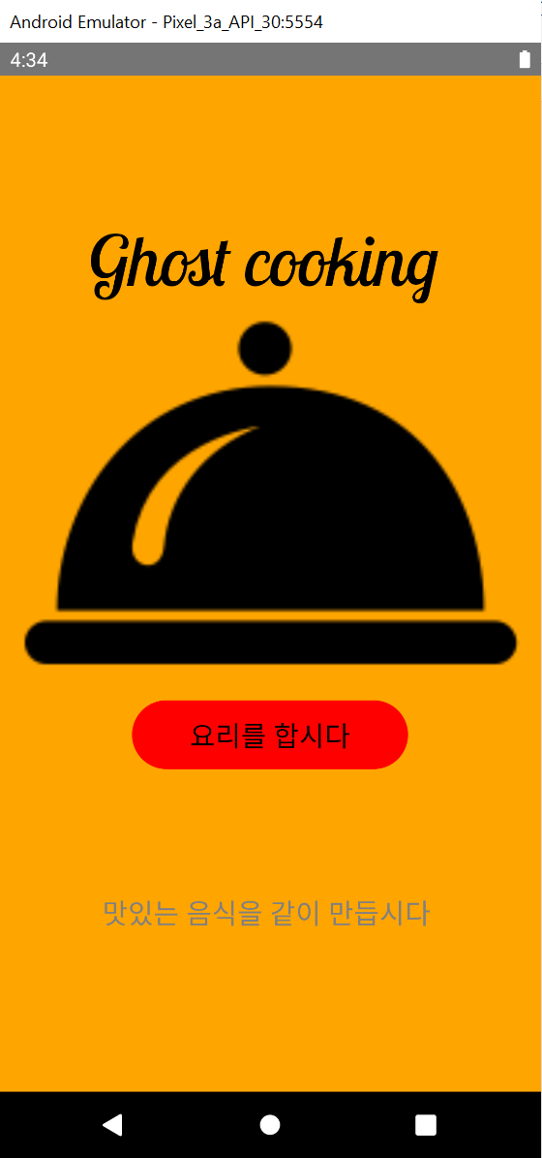

*C. Server*

a) Server function Part

|  |  |  |
| --- | --- | --- |
| class RecipeRecommendation() | _find_recipe() | Indexing similar dishes. Choose one of the recipes that have the highest intersection of ingredients |
| _load_index() | Preprocessing the dataset. Eliminate useless words. |
| find_recipe() | Use to return the recommendation recipe name and recipe methods. |
| make_response_bring() | | Build the NUGU Play builder format response body, which contains backend parameters. Retrieve 1st option backend parameter. |
| make_response_recipe() | | Build the NUGU Play builder format response body, which contains backend parameters. Retrieve 2nd option backend parameter. |
| Make_clear() | | Pre-processing was carried out in advance, but functioned to treat the remaining residues despite the progression. |
| Recipe_Name_Find() | | Using the code used for preprocessing in advance. Also, find recipe information through the name of the dish. |

b) Server Flask Part

When the NUGU speaker sends the request to flask parts, it received the formatted request body using get_json(). After sending it to the functional part, make it into the form of data we want. After that, through the make_response mentioned above, the NUGU speaker recognizes the backend parameter and answers the parameter to the user.

# ARCHITECTURE DESIGN & IMPLEMENTATION

*A. Overall Architecture*

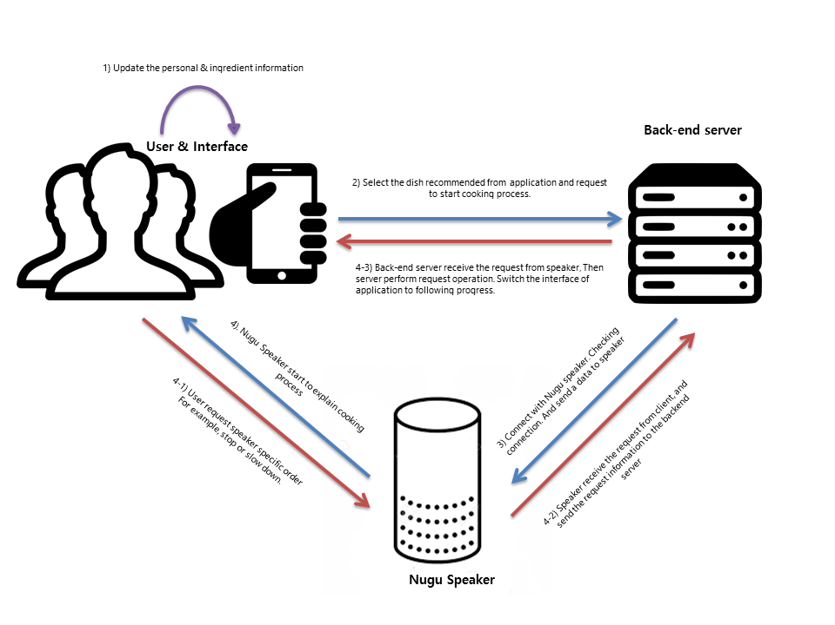

*B. Directory Organization*

|  |  |  |
| --- | --- | --- |
| Directory | File Names | Module Name |
| App | App.js  AppButton.js  AppTextInput.js  Allergy.js  AllergyStyles.js  ConfirmSignUp.js  CookingStart.js  Home.js  Ingredient.js  IngredientStyles.js  SignIn.js  SignUp.js  styles.js | Application |
| Dataset | recipe.json  recipe.xml  Recipe_dataset.csv | Data |
| SE | SE Document.pdf | Documentation |
| root | Backend.py | Backend |

# USE CASES

## SKT NUGU AI SPEAKER

a) Installation

If the user purchases the NUGU Speaker, completes the speaker setup, and installs the NUGU application on the user's smartphone, the user is ready to use Ghost CooKKing. If you press the menu in the upper left corner on the main page of the NUGU application on your smartphone, Ghost CooKKing exists in the useful function tab of the NUGU Play category.

Our service does not need to sign up for an account, so all users have to do is just call the CooKKing by the NUGU Speaker.

b) Starting Application

There are some ways to call Cooker from NUGU Speaker.

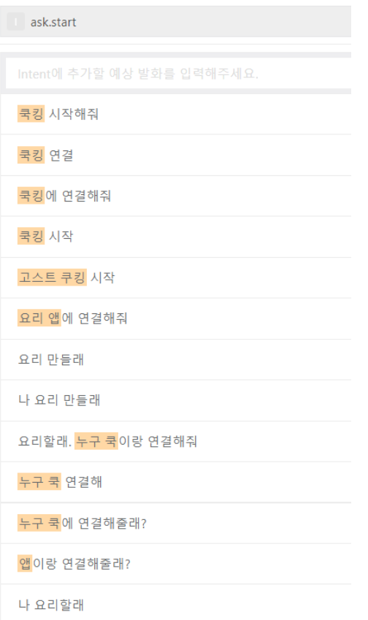

- “Aria, connect to CooKKing”.

- “Aria, connect to NUGU Cook”.

- “Aria, start CooKKing”.

- …etc

Since the recognition rate of NUGU Speaker decreases significantly as the length of the command increases, we limited the calling as just a word "NUGU Cook". Also, there are some other random cooking recommendation services that SKT provides - that is, by calling NUGU Speaker "Aria, start recipe recommendation". So as we add some other ways to call Cooker, to not decrease the recognition rate. In short, we made it simple.

3) Main Function

a) recommend recipe based on ingredients in refrigerator

The NUGU Speaker asks user to choose function (a or b). When user chooses number 1(a), then NUGU asks what ingredients user have. As NUGU receives that data, then it will give random recipe based on ingredients that user said. If you skip the function choose or ingredient input, NUGU Speaker will ask you again about the input information. If NUGU Speaker still does not receive the information from user, the service will be terminated immediately because Cooker service cannot process the command. When NUGU Speaker receives a normal command, it sends it to Flask server and call some recipe datasets.

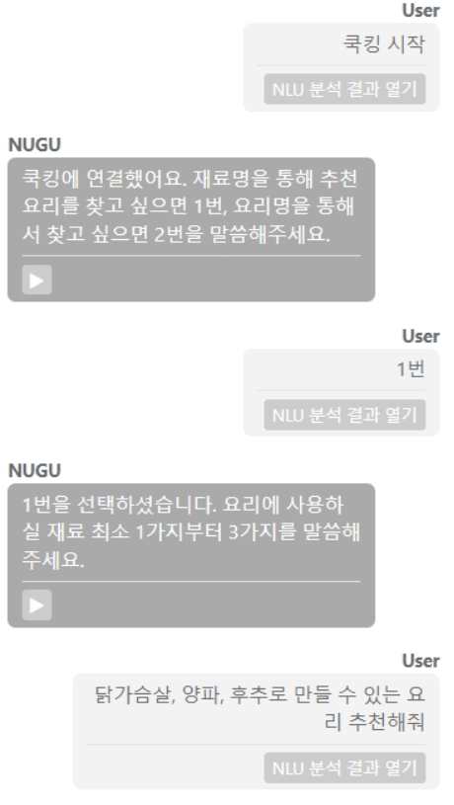

b) provide recipe information that user wants to cook

When user chooses number 2(b), then NUGU Speaker asks recipe that user wants to cook. As NUGU receives the recipe name from user, it will search the most fit recipe name from the database. Just like main function a, if you skip the function choose or ingredient input, NUGU Speaker will ask you again about the input information. If NUGU Speaker still does not receive the information from user, the service will be terminated immediately because Cooker service cannot process the command. When NUGU Speaker receives a normal command, it sends it to Flask server and call some recipe datasets. When NUGU Speaker receives a normal command, it sends to Flask server and call a recipe name, ingredients, and cooking steps.

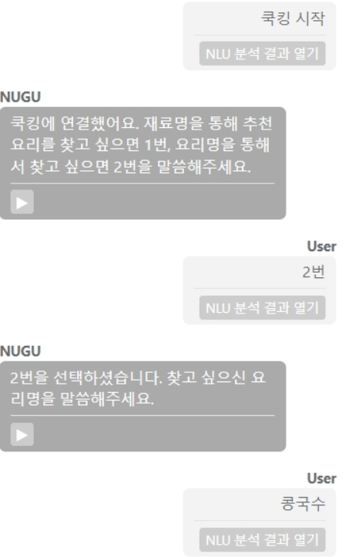

c) Next phase

There are recipes that have a longer cooking process than we thought. General recipes also have a basic cooking process of four or more steps. NUGU Speaker is sensitive to the volatility of information, because it operates in a speaking situation. so we divided cooking process into three stages, and the "next" command is uttered in the middle to move on to each stage.

